AWS Deployment Assignment
Student: Chandan Vishwakarma
GitHub repository:
AWS Region:
Application: Express frontend + Flask backend + MongoDB Atlas
Replace every value in angle brackets. Never put AWS access keys, MongoDB passwords, or real .env files in this folder or in GitHub.
1. Application Details
This repository contains:
- Express frontend: port 3000
- Flask API: port 5000
- Backend health check: /health
- Frontend health check: /health
- MongoDB: MongoDB Atlas, configured through MONGODB_URI
The frontend reads the backend address from the Express /config endpoint. For an EC2 deployment, set BACKEND_URL to the backend's reachable HTTP URL. Set Flask CORS_ORIGINS to the frontend URL.
2. AWS Safety and Prerequisites
- Select one AWS Region and use it consistently.
- Enable billing alerts in Billing and Cost Management > Budgets.
- Create or confirm a key pair, for example <aws-key>.pem.
- Use an Ubuntu 24.04 LTS EC2 AMI and a t2.micro or t3.micro instance only where the Free Tier eligibility shown in your account allows it.
- In each security group, allow:
  - SSH 22 from My IP only
  - TCP 3000 from 0.0.0.0/0 when the Express page is public
  - TCP 5000 only from the frontend security group when possible; use 0.0.0.0/0 temporarily only for testing
- MongoDB Atlas Network Access must allow the EC2 public IP, or a deliberately configured development CIDR.
Screenshot to capture: EC2 instance summary, security-group inbound rules, selected Region, and the billing budget.
3. Common EC2 Preparation
SSH into the instance:
chmod 400 <aws-key>.pem
ssh -i <aws-key>.pem ubuntu@<EC2_PUBLIC_IP>

Install the runtime and Docker tools needed by the chosen deployment:
sudo apt update
sudo apt install -y git curl python3-venv python3-pip nodejs npm
node --version
python3 --version

Clone the project:
git clone <GITHUB_REPOSITORY_URL> app
cd app

Create the backend environment file. Use a strong secret and the real MongoDB Atlas URI only on the server:
nano backend/.env

MONGODB_URI=mongodb+srv://<user>:<password>@<cluster>/<database>?retryWrites=true&w=majority
MONGODB_DATABASE=first_project
MONGODB_COLLECTION=submissions
FLASK_SECRET_KEY=<long-random-secret>
FLASK_DEBUG=false
CORS_ORIGINS=http://<FRONTEND_HOST>:3000

Task 1: Single EC2 Instance
1.1 Start Flask
On one EC2 instance:
cd ~/app/backend
python3 -m venv venv
. venv/bin/activate
pip install -r requirements.txt
nohup gunicorn --bind 0.0.0.0:5000 --workers 2 --timeout 60 app:app > ~/backend.log 2>&1 &
curl http://localhost:5000/health

Expected response:
{"service":"backend","status":"ok"}
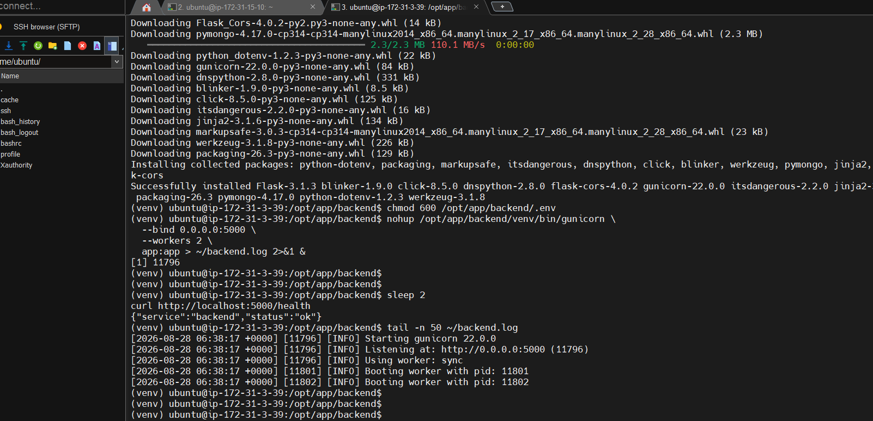
1.2 Start Express
Set Express to call the Flask service through the same EC2 public IP:
cd ~/app/frontend
printf 'PORT=3000\nBACKEND_URL=http://<EC2_PUBLIC_IP>:5000\n' > .env
npm install --omit=dev
nohup npm start > ~/frontend.log 2>&1 &
curl http://localhost:3000/health

Open http://<EC2_PUBLIC_IP>:3000 in a browser and test search, backend status, and form submission.
Required screenshots:
- single-01-ec2.png: running EC2 instance and public IPv4 address
- 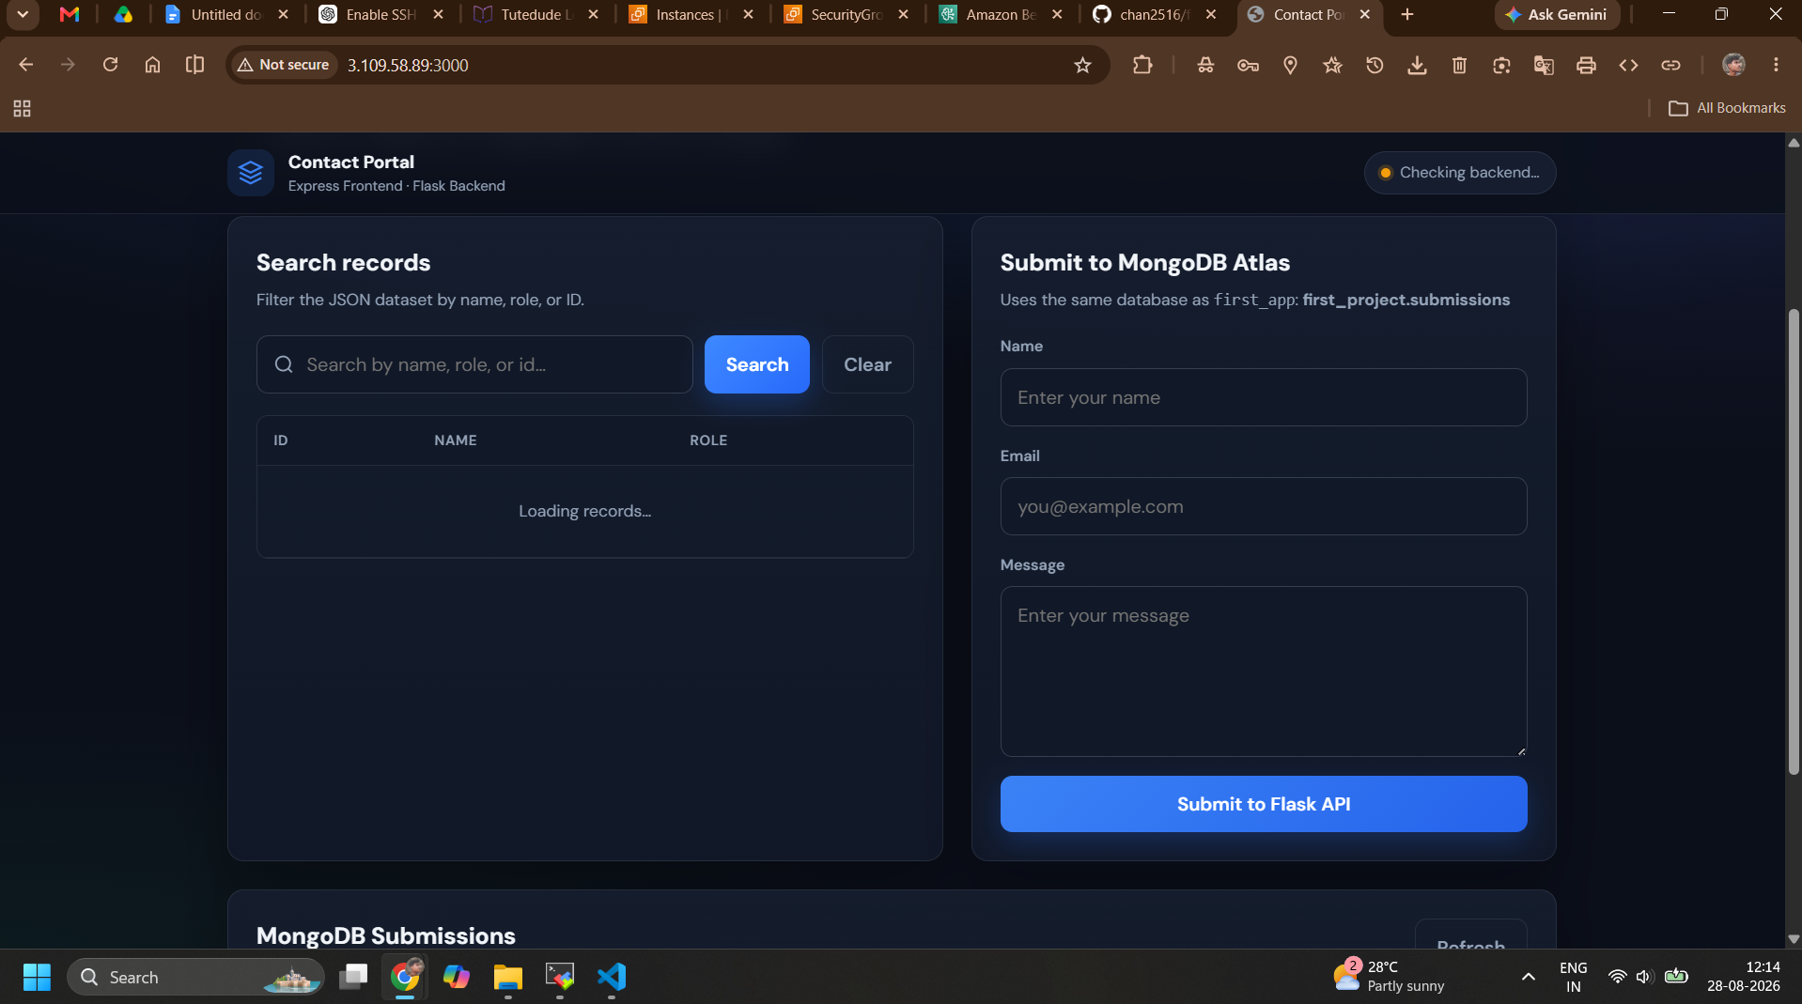
- single-02-security-group.png: ports 22, 3000, and 5000
- 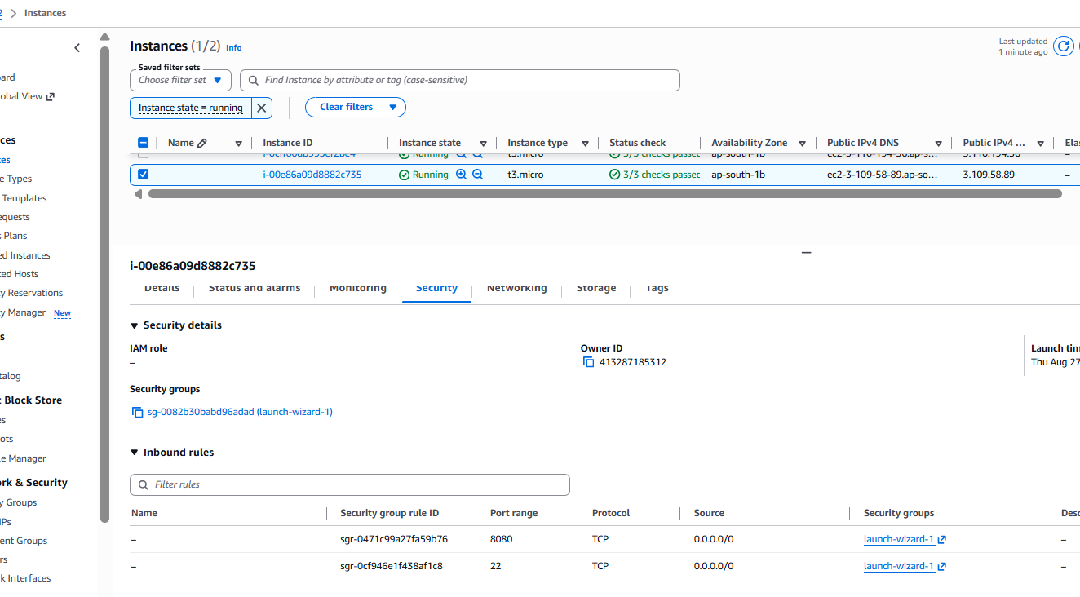
- 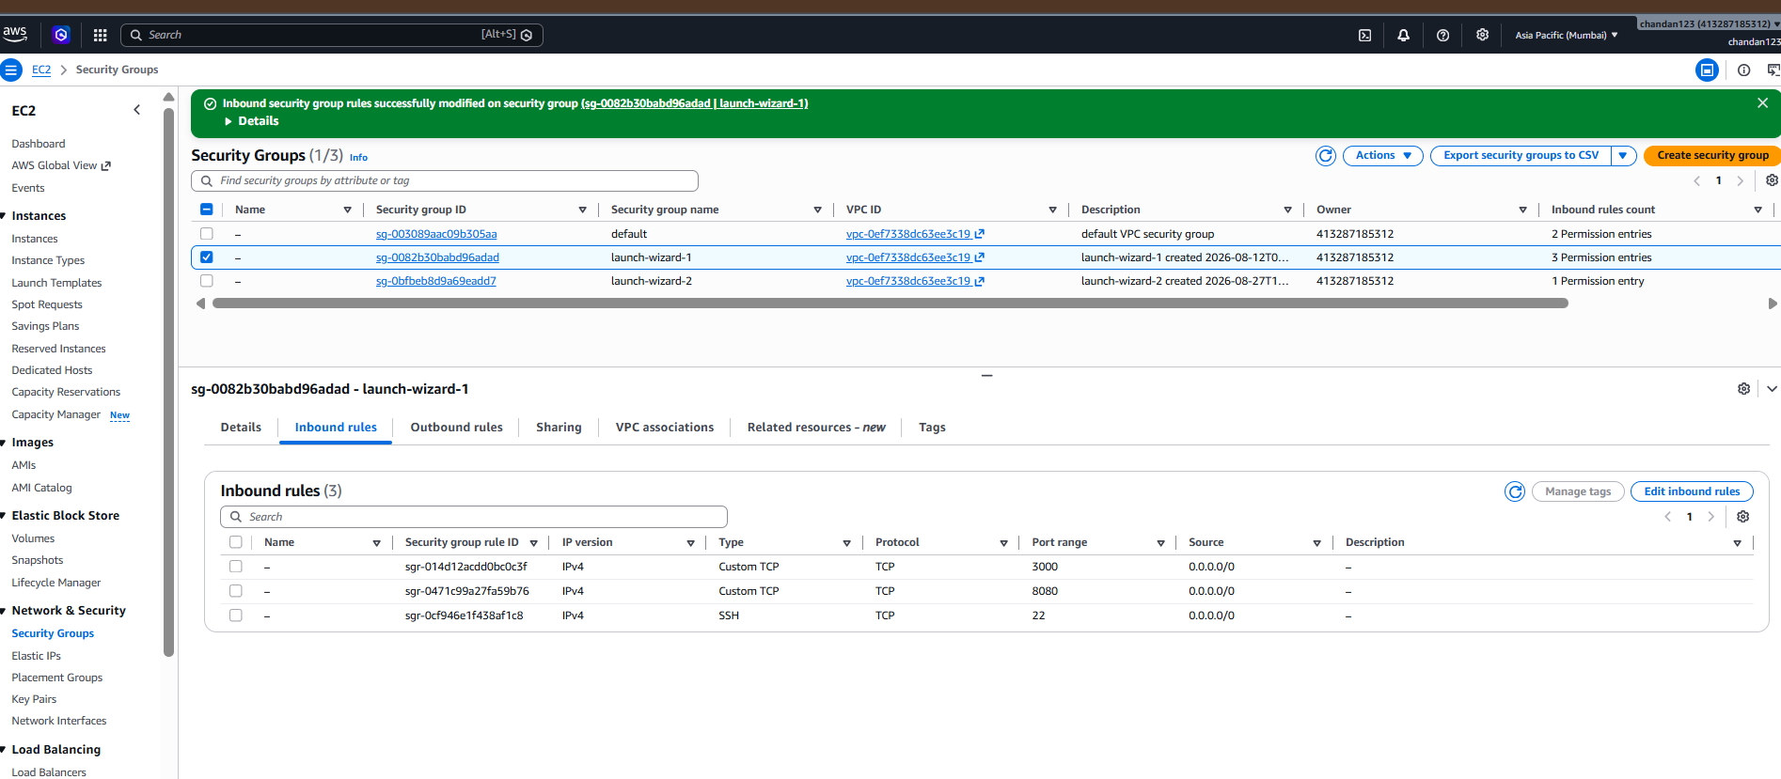
- 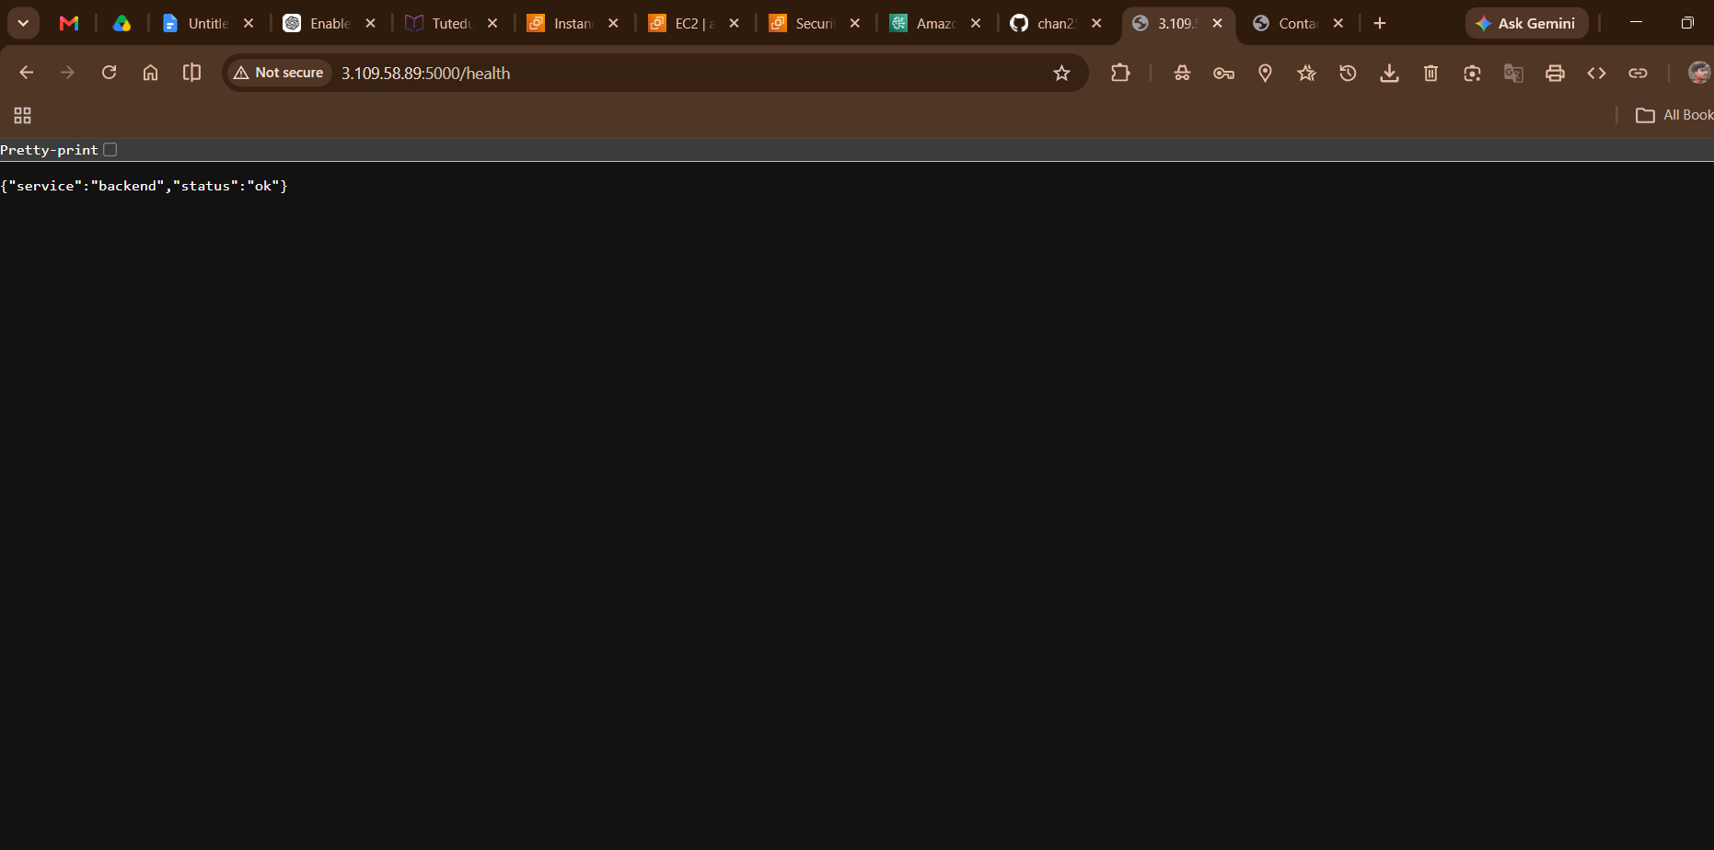
- single-03-commands.png: installation and startup commands
- Run these commands on the EC2 server.

- **Backend**

- ```bash
- sudo chown -R ubuntu:ubuntu /opt/app
- sudo apt update
- sudo apt install -y python3-full python3-venv python3-pip nodejs npm

- cd /opt/app/backend
- python3 -m venv venv
- source venv/bin/activate
- pip install -r requirements.txt

- chmod 600 /opt/app/backend/.env

- nohup /opt/app/backend/venv/bin/gunicorn \
- --bind 0.0.0.0:5000 \
- --workers 2 \
- app:app > ~/backend.log 2>&1 &

- sleep 2
- curl http://localhost:5000/health
- ```

- Expected:

- ```json
- {"service":"backend","status":"ok"}
- ```

- **Frontend**

- ```bash
- cd /opt/app/frontend
- nano .env
- ```

- Add:

- ```env
- PORT=3000
- BACKEND_URL=http://3.109.58.89:5000
- ```

- Save with `Ctrl+O`, `Enter`, then `Ctrl+X`.

- Continue:

- ```bash
- npm install --omit=dev

- nohup npm start > ~/frontend.log 2>&1 &

- sleep 2
- curl http://localhost:3000/health
- ```

- Expected:

- ```json
- {"status":"ok","service":"frontend","backend_url":"http://3.109.58.89:5000"}
- ```

- Open the application in your browser:

- ```text
- http://3.109.58.89:3000
- ```

- Check logs if necessary:

- ```bash
- tail -n 50 ~/backend.log
- tail -n 50 ~/frontend.log
- ```

- Make sure the EC2 security group allows inbound TCP `3000` and `5000`. Also reset the Atlas password and Flask secret shown in the shared file before using this deployment publicly.

- single-04-health.png: both curl health responses

- single-05-browser.png: application open at http://<EC2_PUBLIC_IP>:3000
Record in the submission:
- Frontend URL: http://3.109.58.89:3000/health
- Backend URL: http://3.109.58.89:5000/health
- Result: working
Task 2: Separate EC2 Instances
Create two EC2 instances in the same Region:
- Backend instance: 13.233.96.228
- Frontend instance: 3.109.58.89
Use separate security groups. The frontend security group needs SSH and port 3000. The backend security group needs SSH and port 5000 restricted to the frontend instance security group, plus SSH from your IP.
2.1 Backend instance
git clone <GITHUB_REPOSITORY_URL> app
cd app/backend
nano .env

Set:
MONGODB_URI=mongodb+srv://<user>:<password>@<cluster>/<database>?retryWrites=true&w=majority
MONGODB_DATABASE=first_project
MONGODB_COLLECTION=submissions
FLASK_SECRET_KEY=<long-random-secret>
FLASK_DEBUG=false
CORS_ORIGINS=http://<FRONTEND_PUBLIC_IP>:3000

Start it:
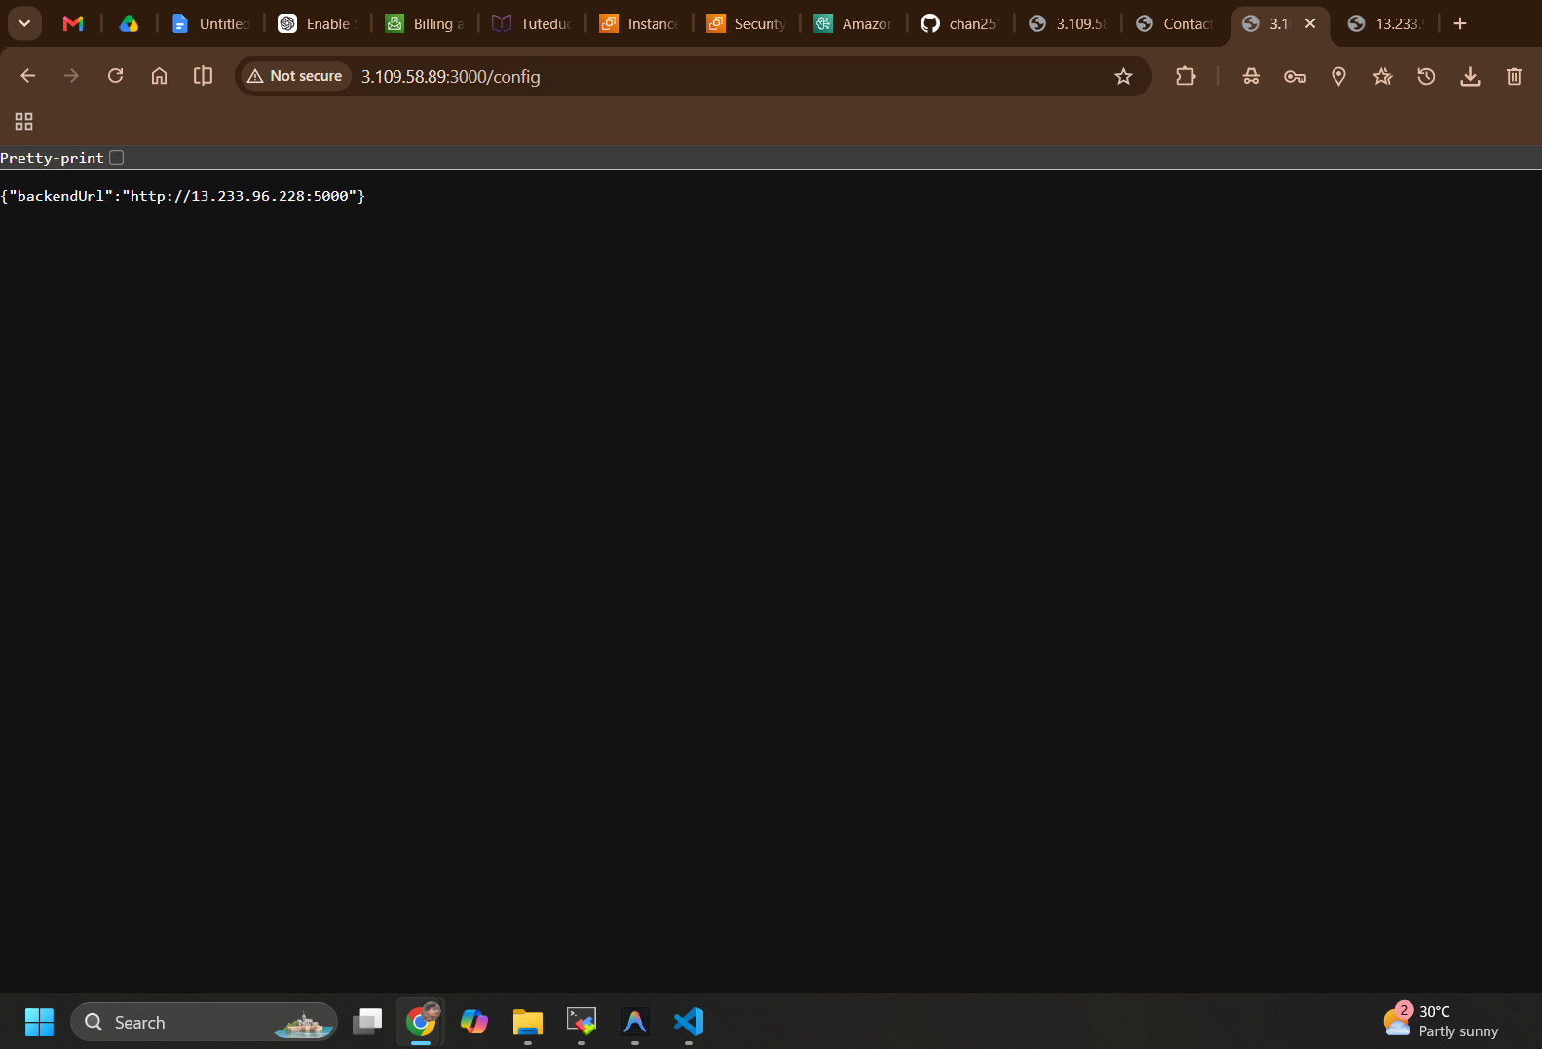
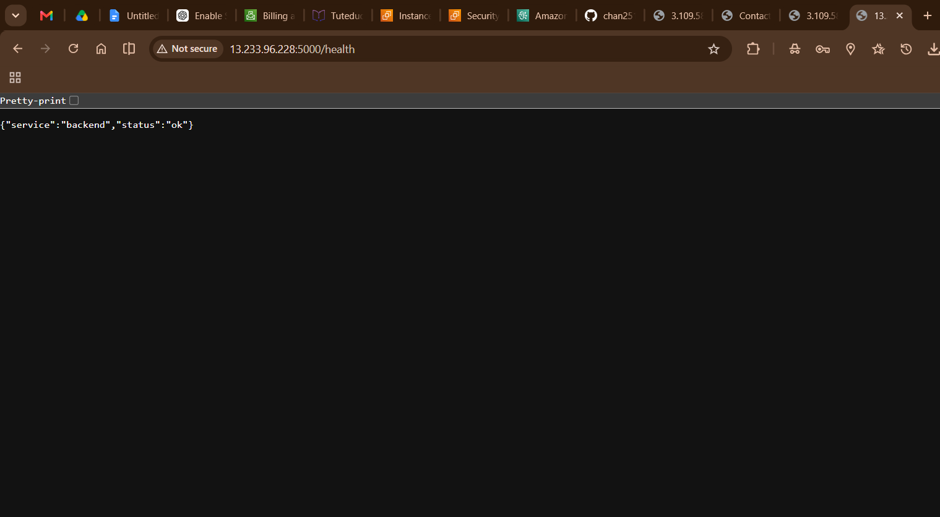
python3 -m venv venv
. venv/bin/activate
pip install -r requirements.txt
nohup gunicorn --bind 0.0.0.0:5000 --workers 2 app:app > ~/backend.log 2>&1 &
curl http://localhost:5000/health

2.2 Frontend instance
git clone https://github.com/chan2516/full_stack_app.git app
cd app/frontend
printf 'PORT=3000\nBACKEND_URL=http://<BACKEND_PUBLIC_IP>:5000\n' > .env
npm install --omit=dev
nohup npm start > ~/frontend.log 2>&1 &
curl http://localhost:3000/health

Open http://<FRONTEND_PUBLIC_IP>:3000 and verify that the page can call the backend. If the browser reports a CORS error, confirm that backend CORS_ORIGINS exactly matches the frontend URL and restart Gunicorn.
Required screenshots:
- separate-01-two-instances.png: both EC2 instances and public IPs
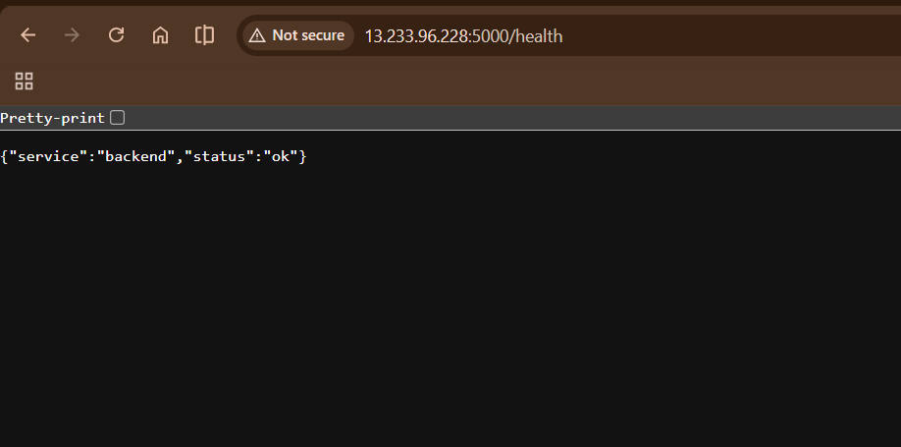
- separate-02-security-groups.png: frontend and backend rules
- 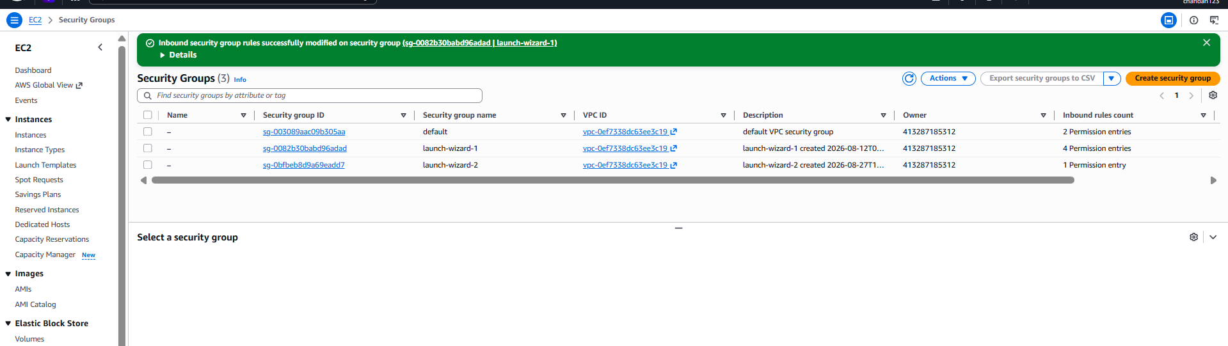
- 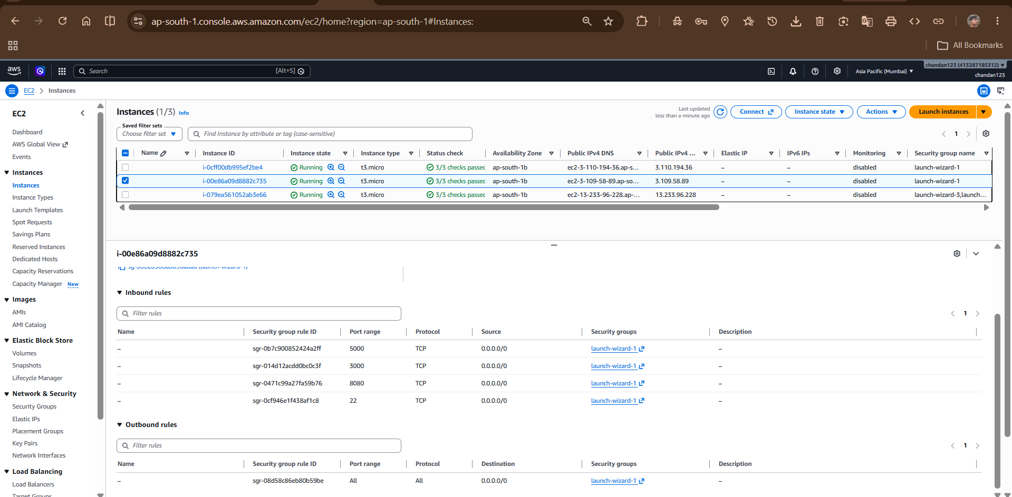
- separate-03-backend-health.png: backend health response
- 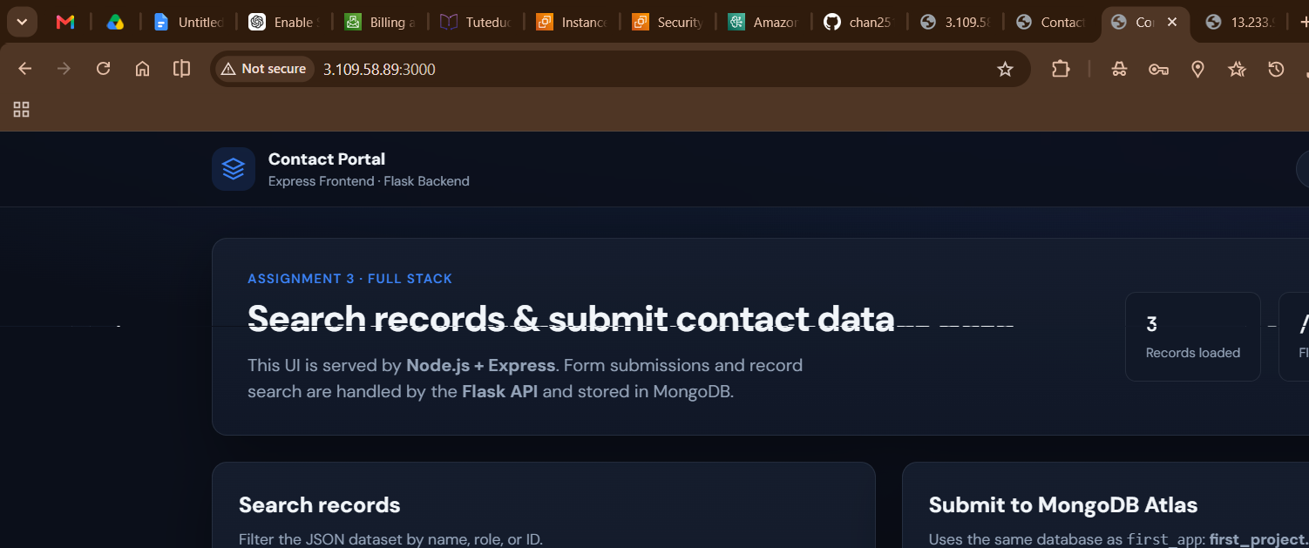
- separate-04-frontend-health.png: frontend health response
- 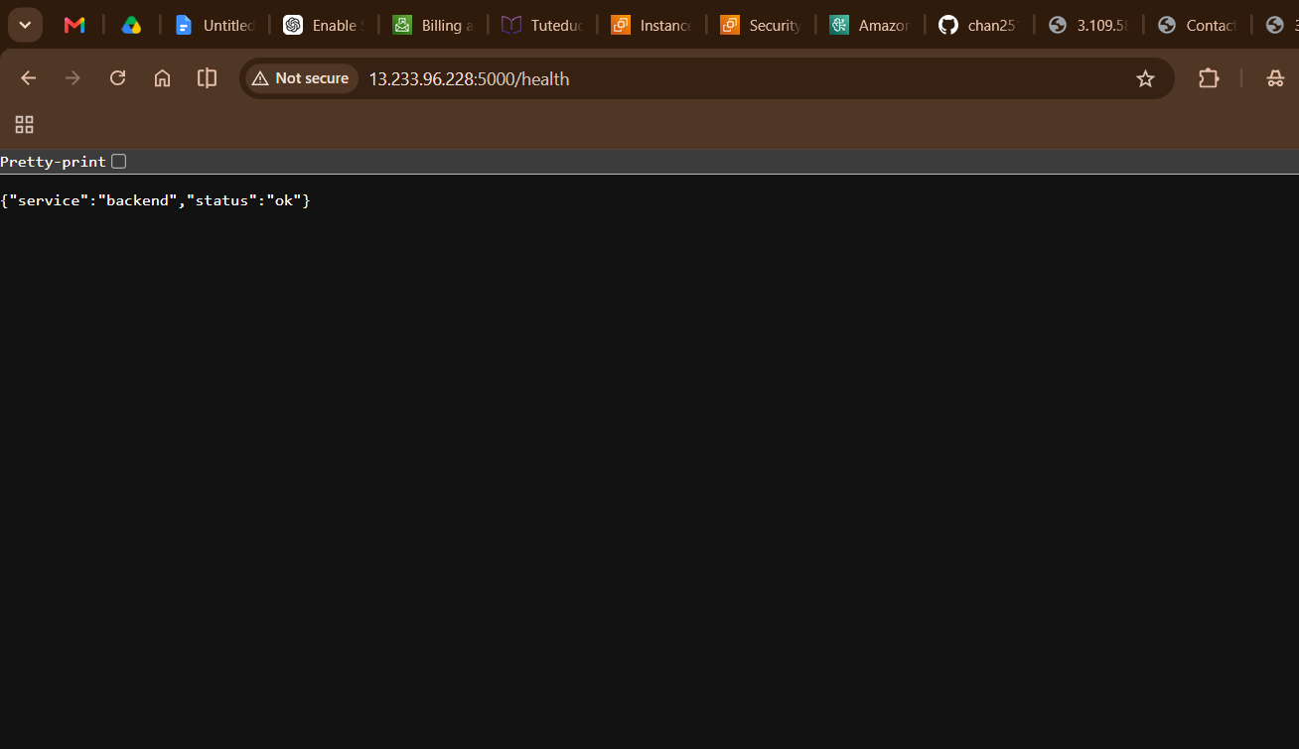
- separate-05-browser.png: working application and backend-online status
- 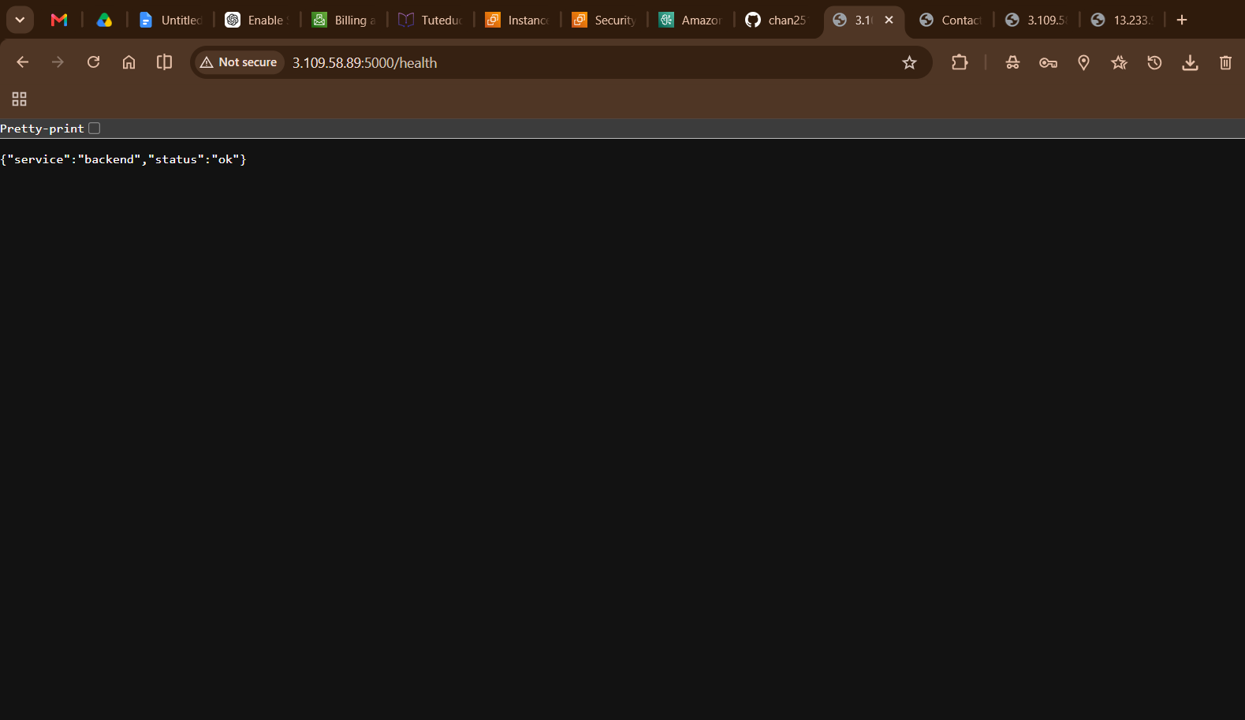
Record in the submission:
- Frontend URL: http://3.109.58.89 :3000
- Backend URL: http://13.233.96.228 :5000
- Result: working

- Task 3: Docker with ECR, ECS, and VPC
This task uses the existing backend/Dockerfile, frontend/Dockerfile, and docker-compose.yaml. Build the images from the repository root. ECS tasks should receive the backend URL through the frontend container's BACKEND_URL environment variable.
3.1 Build and test locally
cd app
docker compose --profile local-mongo up --build -d
docker compose ps
curl http://localhost:5000/health
curl http://localhost:3000/health
docker compose --profile local-mongo down

If using MongoDB Atlas instead of the local Mongo container, create a root .env with MONGODB_URI, MONGODB_DATABASE, MONGODB_COLLECTION, FLASK_SECRET_KEY, and CORS_ORIGINS before starting Compose.
Screenshot: ecs-01-local-docker-test.png showing docker compose ps and both health checks.
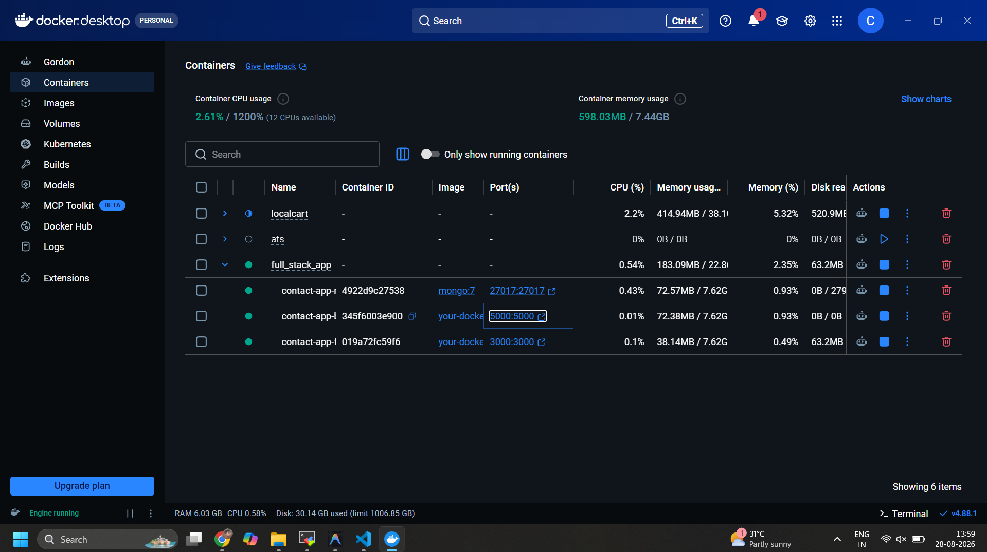
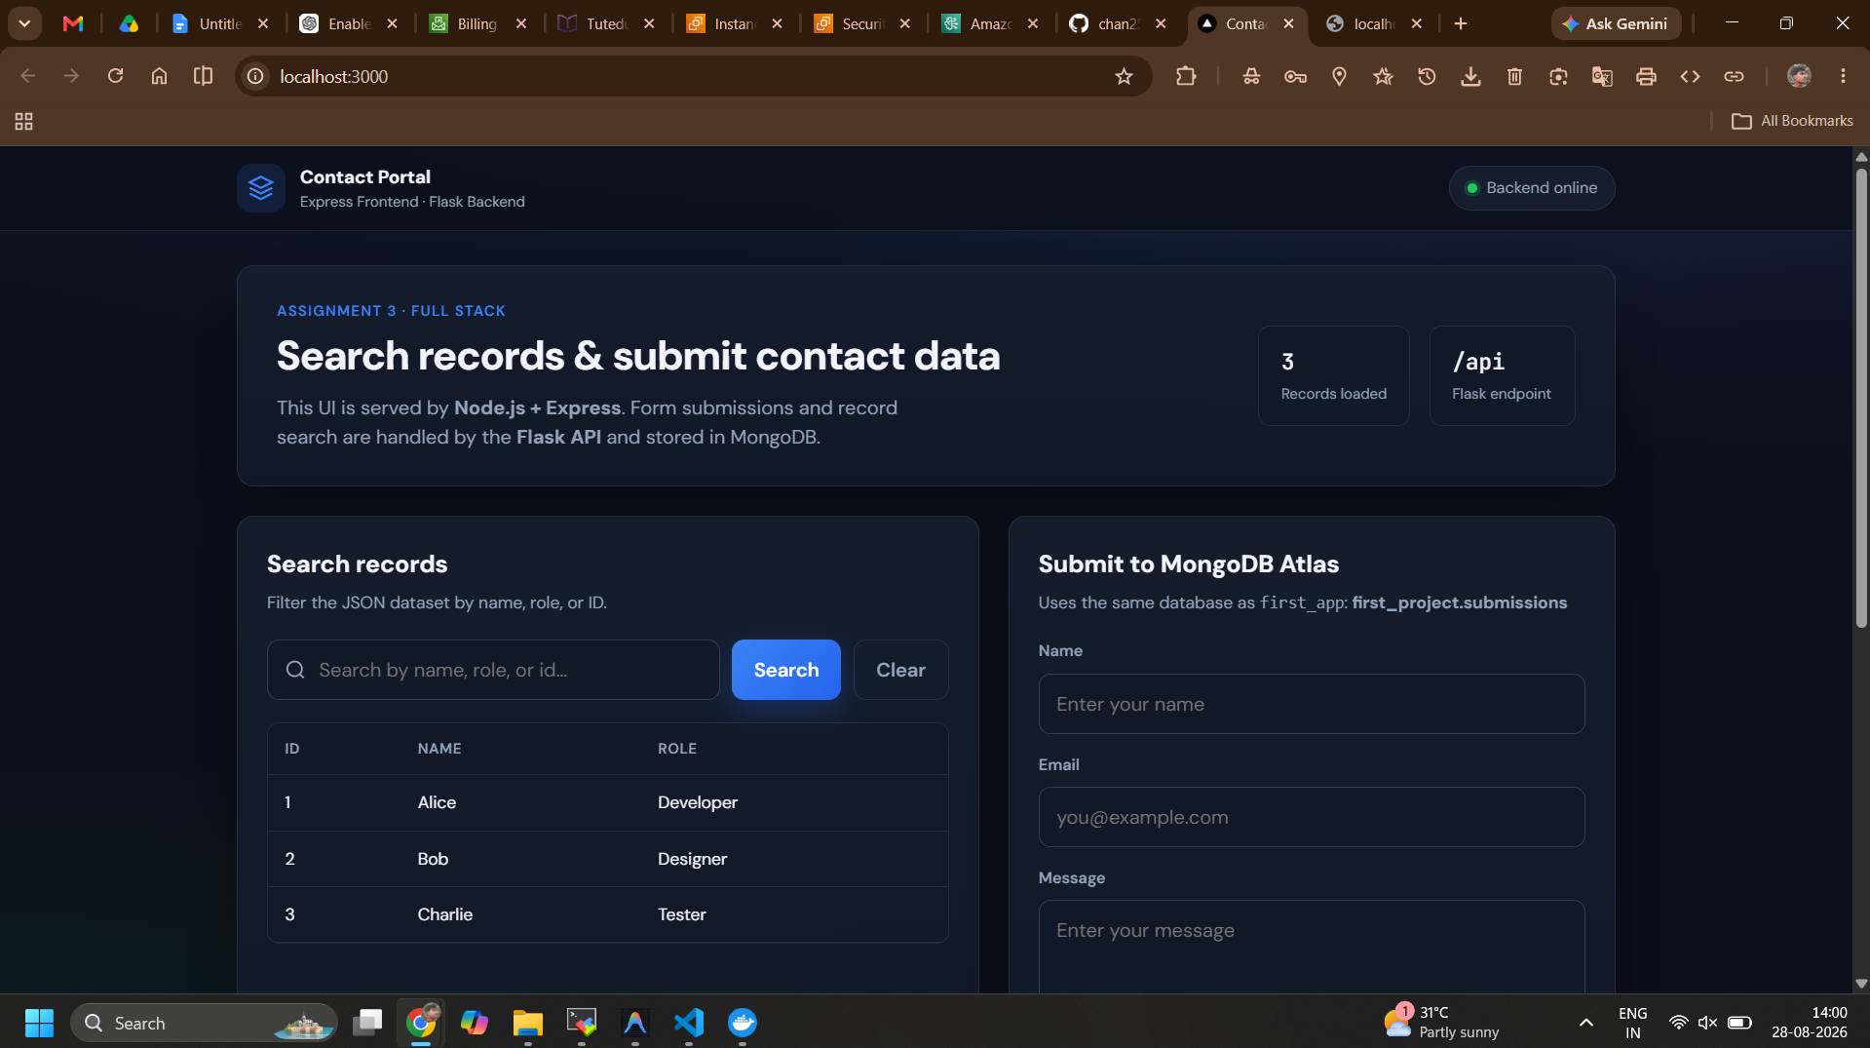
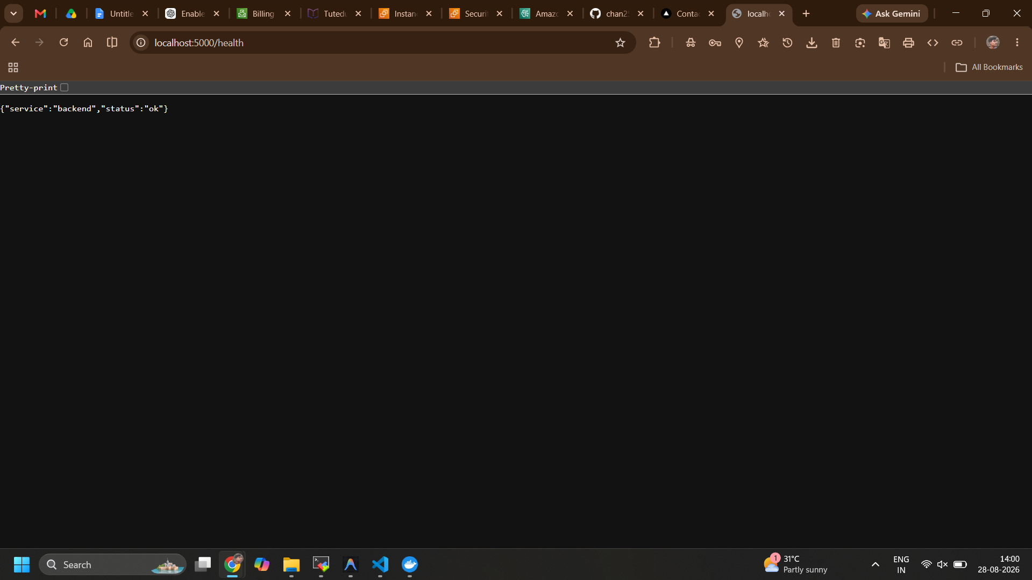
3.2 Create ECR repositories and push images
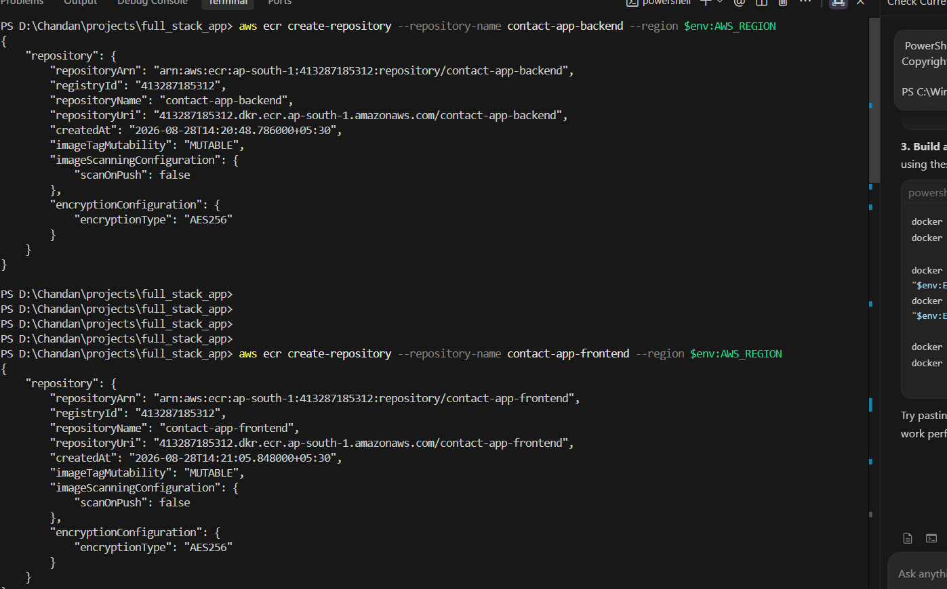
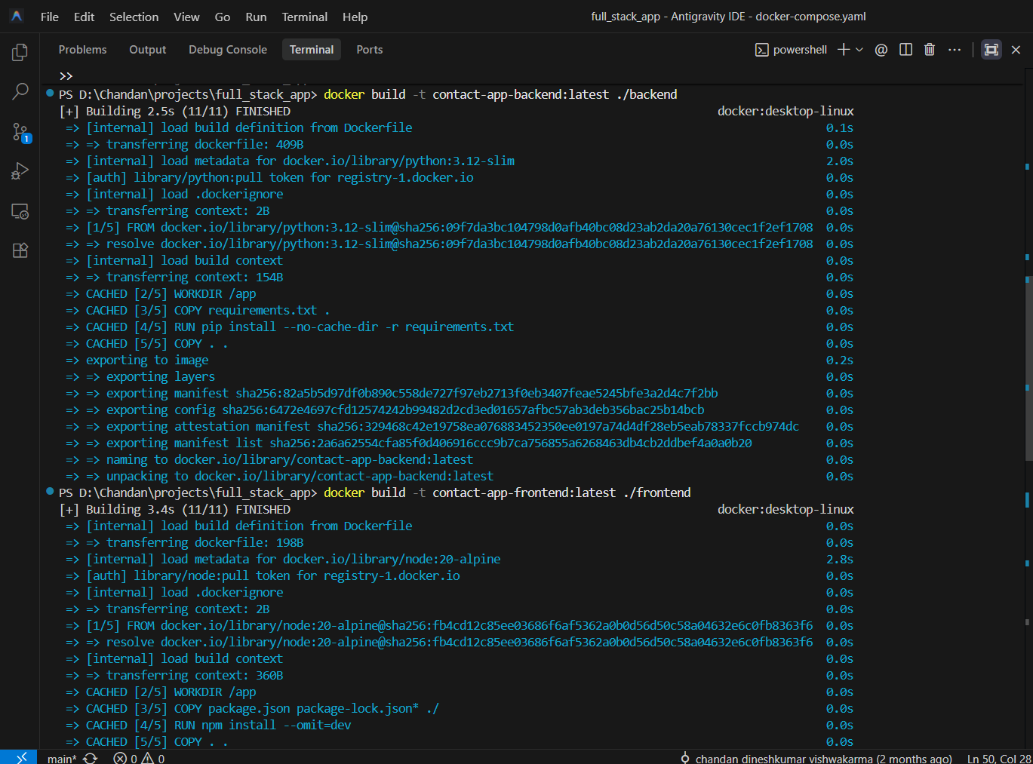
Install and configure AWS CLI on the machine used to build the images:
aws configure
aws sts get-caller-identity
export AWS_REGION=<your-region>
export AWS_ACCOUNT_ID=$(aws sts get-caller-identity --query Account --output text)
export ECR_HOST=$AWS_ACCOUNT_ID.dkr.ecr.$AWS_REGION.amazonaws.com

Create repositories and authenticate Docker:
aws ecr create-repository --repository-name contact-app-backend --region $AWS_REGION
aws ecr create-repository --repository-name contact-app-frontend --region $AWS_REGION
aws ecr get-login-password --region $AWS_REGION | docker login --username AWS --password-stdin $ECR_HOST

Build, tag, and push:
docker build -t contact-app-backend:latest ./backend
docker build -t contact-app-frontend:latest ./frontend
docker tag contact-app-backend:latest $ECR_HOST/contact-app-backend:latest
docker tag contact-app-frontend:latest $ECR_HOST/contact-app-frontend:latest
docker push $ECR_HOST/contact-app-backend:latest
docker push $ECR_HOST/contact-app-frontend:latest
aws ecr describe-images --repository-name contact-app-backend --region $AWS_REGION
aws ecr describe-images --repository-name contact-app-frontend --region $AWS_REGION

Screenshot: ecs-02-ecr-images.png showing both ECR repositories and pushed latest images
.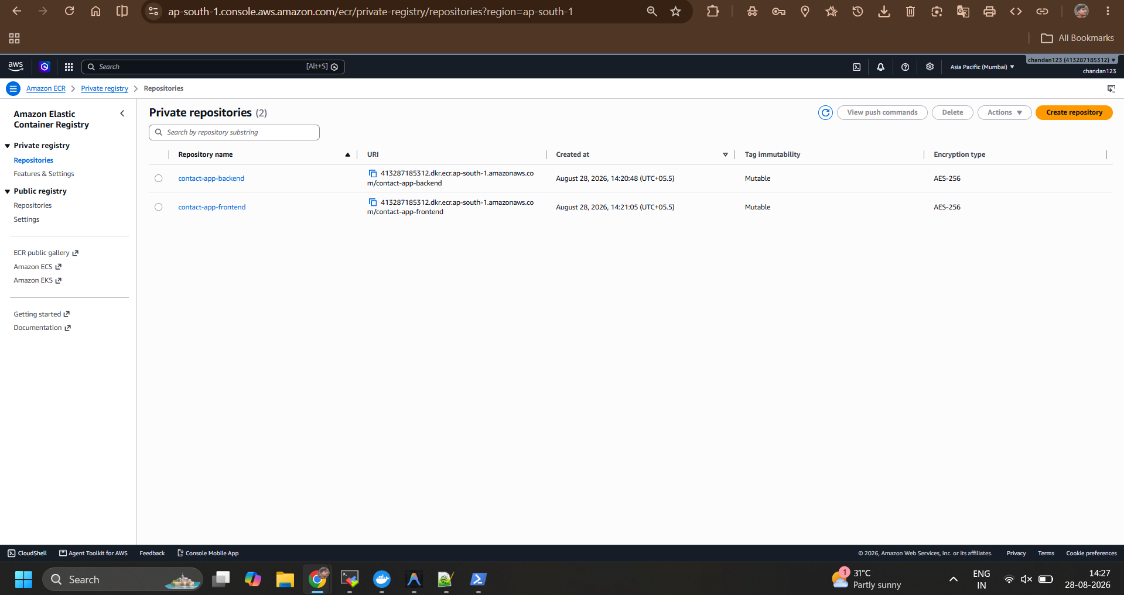
3.3 Create the VPC and ECS resources
In the AWS Console:
- Open VPC > Your VPCs and create a VPC with at least two subnets in different Availability Zones. Create an internet gateway and route table for public subnets.
- Open EC2 > Security Groups and create an ECS security group. Allow HTTP port 3000 from your test IP or the internet, and allow port 5000 only from the frontend task security group.
- Open IAM > Roles and create an ECS task execution role with AmazonECSTaskExecutionRolePolicy. Do not put AWS keys in the application image.
- Open ECS > Clusters and create <contact-app-cluster>.
- Create a task definition with two containers:
  - backend: image <ECR_BACKEND_URI>, container port 5000, environment variables from the task definition or Secrets Manager
  - frontend: image <ECR_FRONTEND_URI>, container port 3000, PORT=3000, BACKEND_URL=http://127.0.0.1:5000
- For a task definition using awsvpc and bridge networking, expose the frontend service on port 3000. Keep both containers in the same task so 127.0.0.1:5000 reaches the backend container.
- Create an ECS service in the cluster using the VPC subnets and ECS security group. Assign a public IP only for a temporary test deployment.
- Wait for the task to become Running, then open the task's public IP at http://<ECS_PUBLIC_IP>:3000.
For a public production-style URL, add an Application Load Balancer and target the frontend service on port 3000. An ALB may create additional charges, so remove it after taking screenshots.
Screenshot checklist:
- ecs-03-vpc.png: VPC, subnets, route table, and internet gateway
- ecs-04-ecs-cluster.png: ECS cluster and running service
- ecs-05-task-definition.png: both container images and ports
- ecs-06-running-task.png: task status, network details, and public IP
- ecs-07-ecr-ecs-browser.png: working application URL
Record in the submission:
- ECR backend URI: <AWS_ACCOUNT_ID>.dkr.ecr.<REGION>.amazonaws.com/contact-app-backend:latest
- ECR frontend URI: <AWS_ACCOUNT_ID>.dkr.ecr.<REGION>.amazonaws.com/contact-app-frontend:latest
- ECS application URL: http://<ECS_PUBLIC_IP>:3000
- VPC ID: <vpc-id>
- ECS cluster: <cluster-name>
- Result: <working / issue and resolution>
4. Cost Cleanup Checklist
After taking the required screenshots and recording URLs:
- Stop both EC2 instances from EC2 > Instances.
- Set ECS service desired count to 0, then delete the ECS service and cluster.
- Delete the ECS task definition revision if no longer needed.
- Delete the ALB, target groups, NAT gateways, and unused Elastic IPs. NAT gateways and load balancers can cost money.
- Delete ECR repositories if the assignment does not require them to remain.
- Remove unused VPC resources after the ECS service is deleted.
- Check Billing > Bills and Cost Explorer.
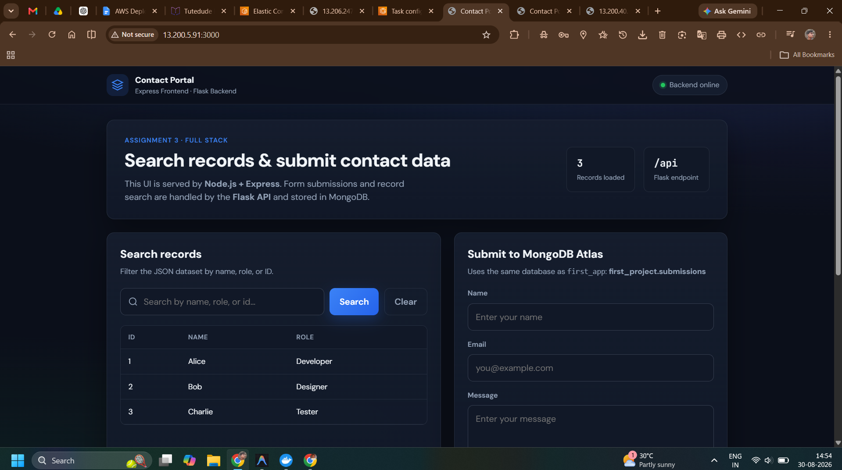
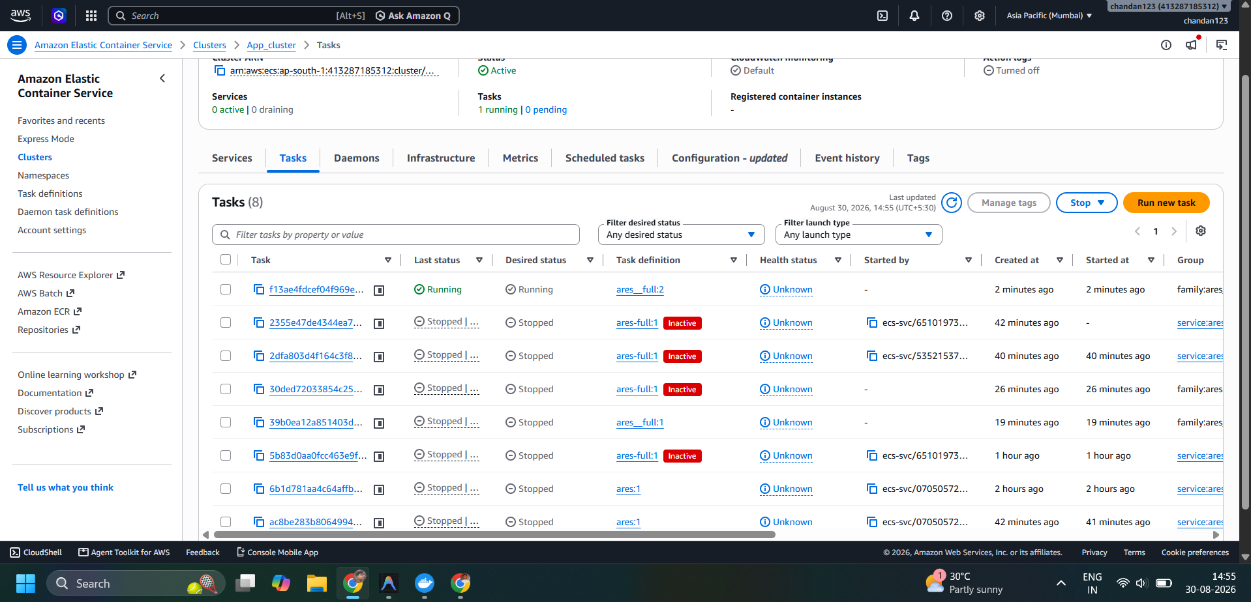
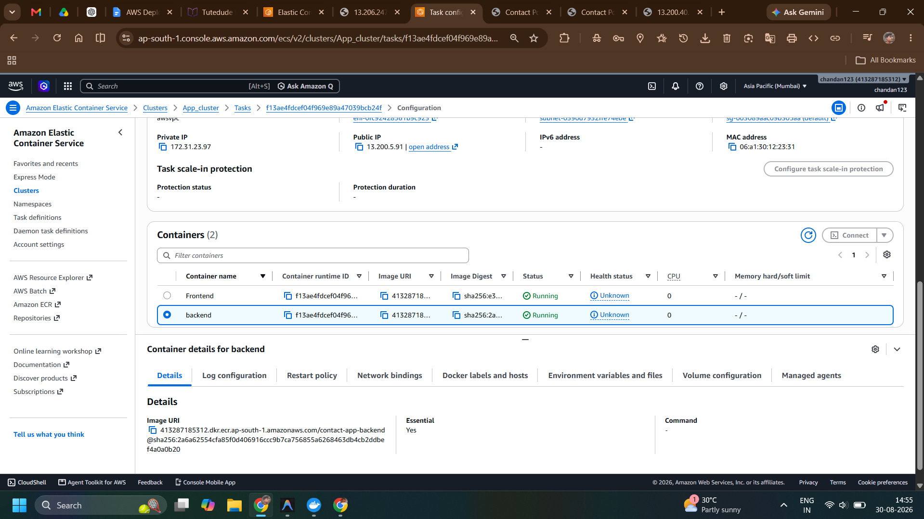
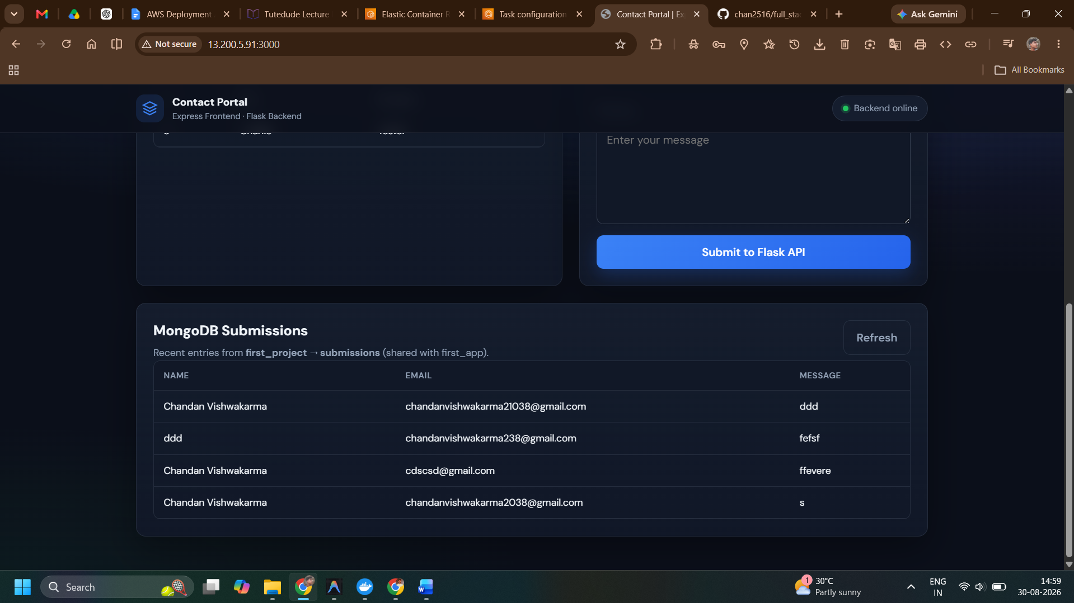
Git hub URL : https://github.com/chan2516/full_stack_app.git

